3- Abstract Factory

- Abstract Factory is a factory of factories. គឺជា Factory ដែលមាន Factory ច្រើននៅក្នុងនឹង គឺវាលាក់ Factory ច្រើនទៀតនៅក្នុងនឹង
- That is a factory pattern hiding the details of object creation and factories or an abstract factory. hides the creation of the factory itself.

Example: on JAXP api

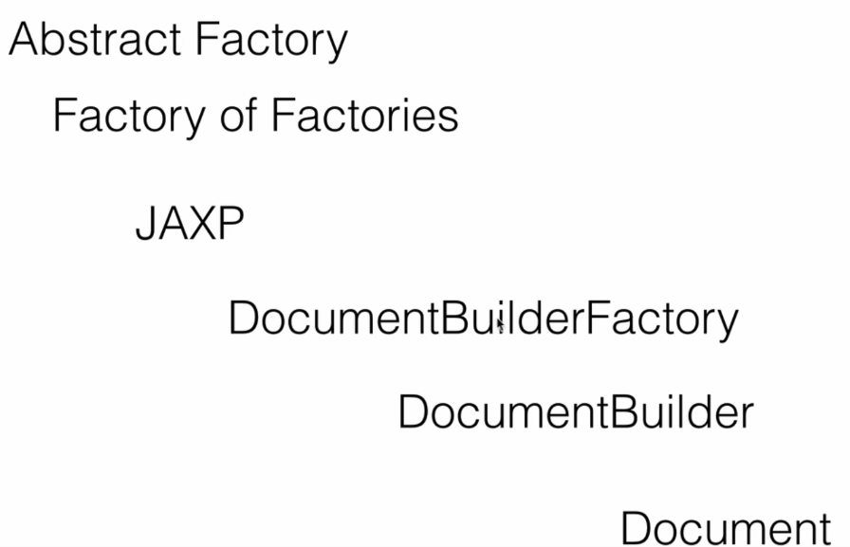

- To write the xml file we need the document then the document have factory to build it is DcoumentBuilder and there are many file from other file that we can wire so it will need the DocumentBuilderFactory (Abstract Factory)
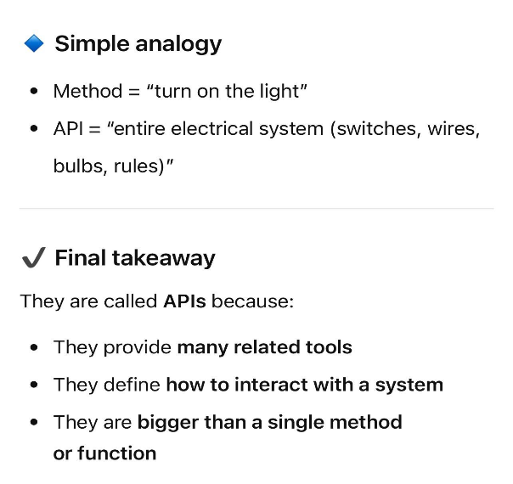

- API យើងគិតដូចជា ឧបករណ៍័ច្រើនបង្កើតបញ្ចូលគ្នាដើម្បីបង្កើតបានអ្វីមួយ។ឧ ដៃកាប់ ទុលវិស ប៉ូឡុង ចឹងវាបញ្ចូលគ្នាបង្កើតបានជា Tools group.
- ចំណែកឯក Function or Method is one tool that can handle one of specific logic
Example1:
DAO Factory (Data Access Transfer Object): It simply is a class that can read write create update data we can have different types of DAO's.
